H.T No
Regulations:
A22

Sreenidhi Institute of Science and Technology
(An Autonomous Institution)
Code No:9A304 Date:20 -January-2025 (FN)

B.Tech II-Year I- Semester External Examination, January-2025 (Regular & Supplementary)
ELECTRICAL CIRCUITS AND NETWORKS-II (EEE)

Time: 3 Hours Max.Marks:60

Note: a) No additional answer sheets will be provided.
b) All sub-parts of a question must be answered at one place only, otherwise it will not be valued.
c) Missing data can be assumed suitably.
Bloom's Cognitive Levels of Learning (BCLL)

Remember | L1 | Apply | L3 | Evaluate | L5
Understand | L2 | Analyze | L4 | Create | L6

Part - A Max.Marks: 6x2=12

Answer all QUESTIONS, EACH QUESTION CARRIES 2 MARKS.

 |  | BCLL | CO(s) | Marks
1 | If a balanced delta load has an impedance of (6+j9)Ω per phase then what is the impedance of each phase in the equivalent star load. | L2 | CO1 | [2M]
2 | Draw the equivalent circuit for inductor and capacitor at t = 0+ when there is no initial energy. | L1 | CO2 | [2M]
3 | Define transfer function. | L2 | CO3 | [2M]
4 | What is condition for symmetry and reciprocity in hybrid parameters? | L1 | CO4 | [2M]
5 | What is a filter? List different types of filters. | L1 | CO5 | [2M]
6 | List out the conditions of a function to possess even symmetry in terms of Fourier series coefficients. | L1 | CO6 | [2M]

Part – B Max.Marks: 6x8=48
ANSWER ALL QUESTIONS. EACH QUESTION CARRIES 8 MARKS.

 |  | BCLL | CO(s) | Marks
7. | Determine the line currents in an unbalanced star connected load supplied from a symmetrical 3 phase 440V system. The branch impedances of the load are and .The phase sequence is RYB. | L3 | CO1 | [8M]
 | OR
8 | What will be the relation between readings on the wattmeter connected to measure power in a three-phase balanced circuit with (a) unity power factor, (b) zero power factor, and (c) power factor = 0.5. | L2 | CO1 | [8M]
9. | Derive the expression for current in a series RL circuit excited by DC voltage. Assume zero initial conditions. | L2 | CO2 | [8M]
 | OR
10 | A 20 µF capacitor in the RC circuit shown has an initial charge of q0 = 500 µC with the polarity as shown. The switch is closed at time t = 0. Find the current transient and the voltage across the capacitor. Find the time at which the capacitor voltage is zero.  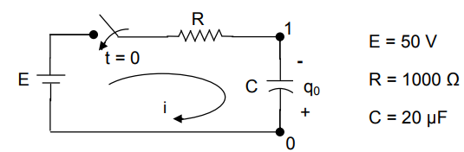 | L3 | CO2 | [8M]
11 | i) Write the necessary conditions for driving point function.  ii) Write the transform formulas for inductor L and capacitor C in 'J' notation and s domain. | L2 | CO3 | [8M]
 | OR
12 | For the given network, find out V₂/V₁  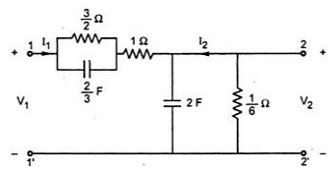 | L3 | CO3 | [8M]
13 | Find the transmission Parameters of the given network as shown in fig.  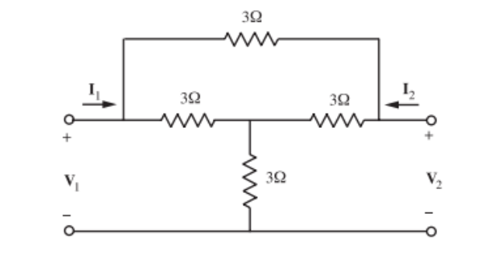 | L2 | CO4 | [8M]
 | OR
14 | Determine the Z-parameters for the network shown in fig.  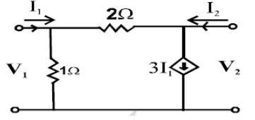 | L4 | CO4 | [8M]
15 | Explain the design procedure of constant ‘k’ band pass filter. | L2 | CO5 | [8M]
 | OR
16 | A constant ‘k’ low pass filter is composed of a symmetrical π section. Each series branch is a 0.02H inductor and shunt branch is a 2µF capacitor. Find  i) Cut-off frequency. ii) Nominal impedance iii) Characteristic impedance at 200Hz and 2000Hz iv) Attenuation at 200Hz and 2000Hz | L3 | CO5 | [8M]
17 | Find the exponential Fourier series for the waveform shown below.  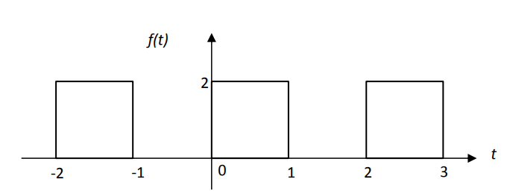 | L2 | CO6 | [8M]
 | OR
18 | Find the exponential Fourier series of the waveform shown in Figure below. Draw the magnitude spectrum.  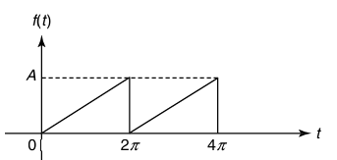 | L4 | CO6 | [8M]

-- 00 -- 00 –

